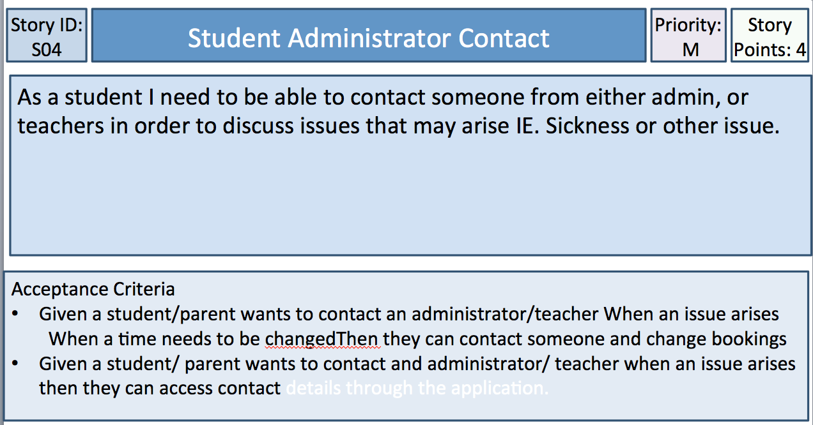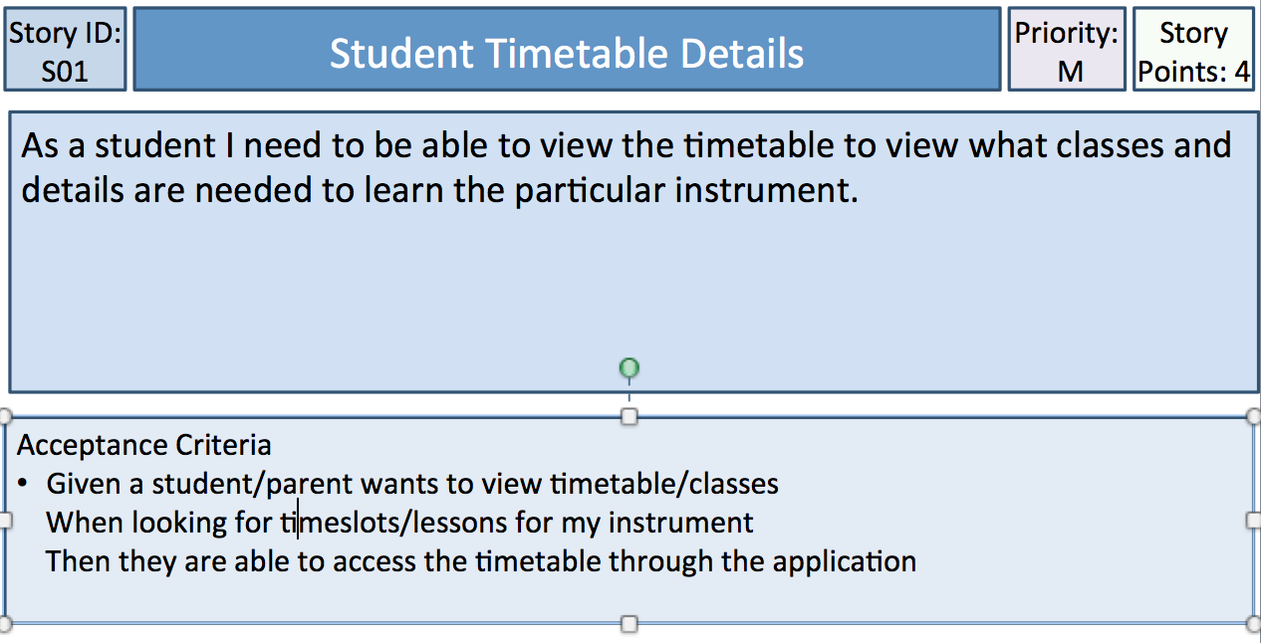

Testing:

This Criteria is based on the students being able to contact the staff as well as parents needing to contact them. This has been satisfied by adding a messaging tab as well as adding a booking tab. This satisfies the contact and booking requirements and it is quite usable and would also rate around 4/5.

Testing:

This Criteria is based on the student being able to access the timetable to view potential classes, languages and the instruments that need to be learned. The time table functionality is present in the app and quite easy to view especially for a student. It is easy to see the data needed to decide the things required within this acceptance Criteria. Overall on a scale of 1-5 I would give the usability of the timetable a 4/5. This is because it is easy to use however could be a little more appealing.

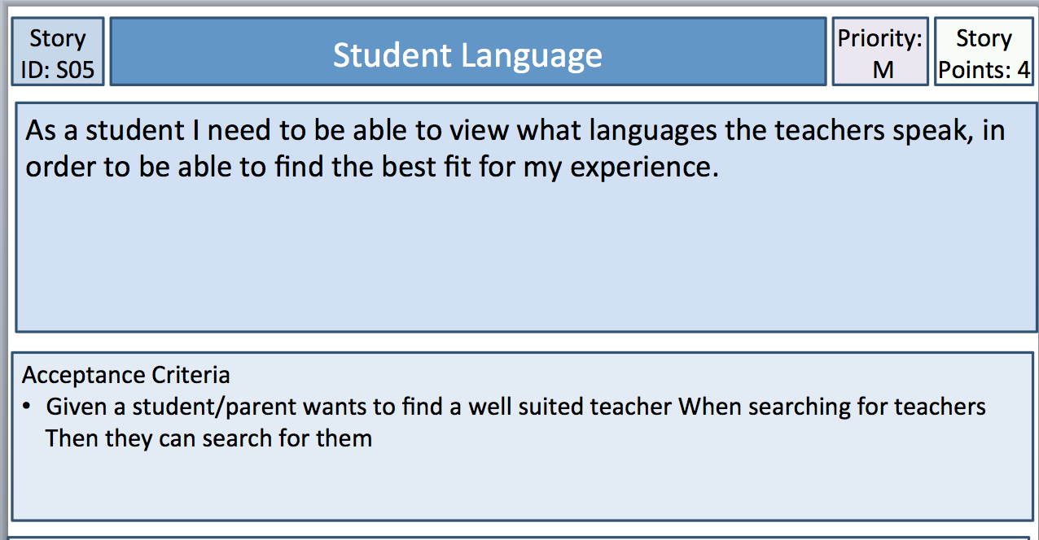

Testing:

This Criteria is about wanting to find well suited teachers, this information can be accessed through the timetable and is quite usable. This satisfies the requirements for being able to find teachers as all of the info on what languages and what instruments are being taught is within the database and within the timetable. As stated before the timetable is 4/5 because it could be more visually appealing however this is a minor issue.

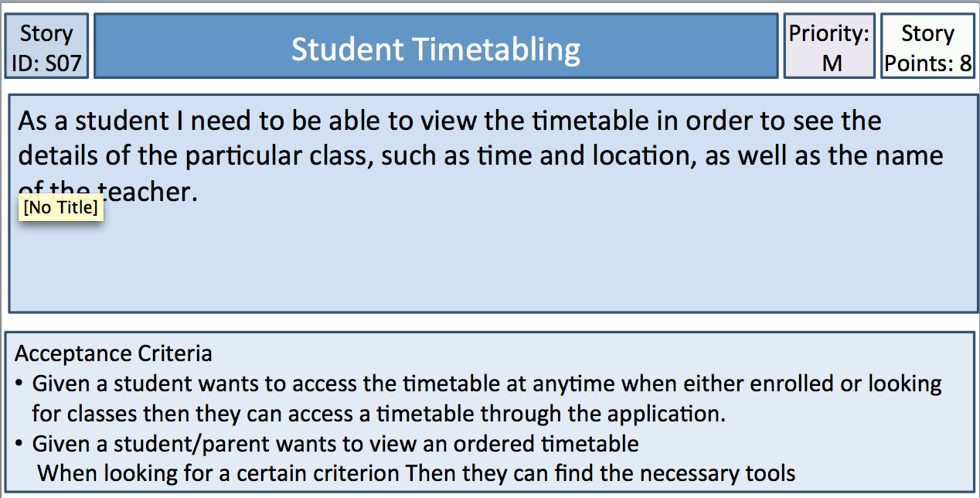

Testing:

The timetable needs to be viewable at anytime and at this current point it is able to be accessed at any point and the classes can be accessed. These two criterions are pretty much the same as the ordered timetable can be viewed as well. The user experience would be considered to be 4/5 as it is still to do with the Timetable itself.

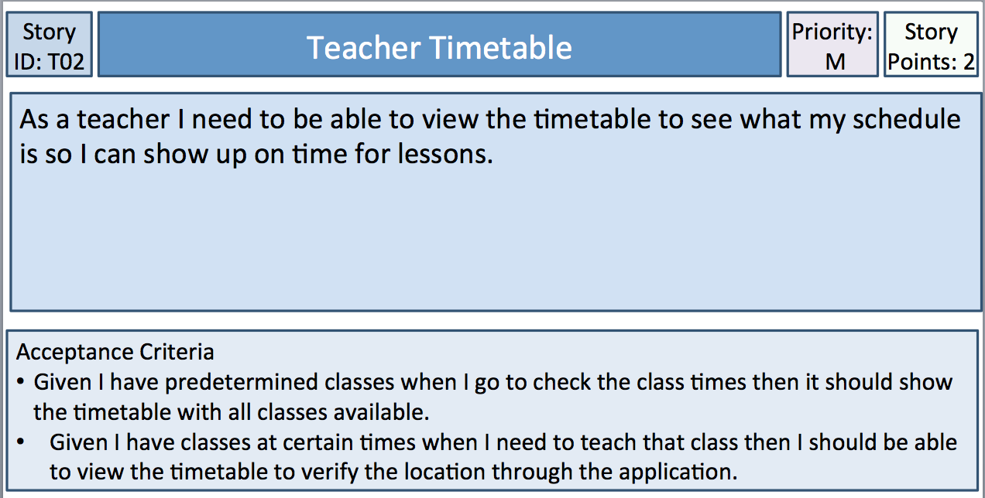

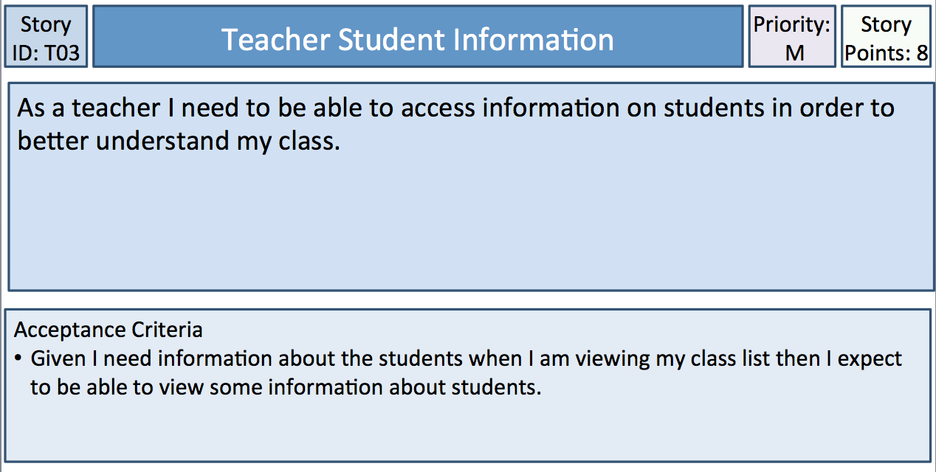

Testing:

This is about Teachers being able to access the predetermined class list by looking at the Timetable itself. This is also about the Timetable user experience and is much the same as teachers can also view the timetable whenever needed, however the timetable is around 4/5 in user experience and could be improved slightly in terms of visual effect but it satisfies the criteria.

Testing:

This Criteria is about teachers being required to access information regarding the students within the class list. This can be done through accessing the data which holds information regarding the students. This feature could be made more usable and would gain a usability rating of around about 4 out of 5 it could still use some work however it is still quite satisfying in terms of the requirements for this criterion.

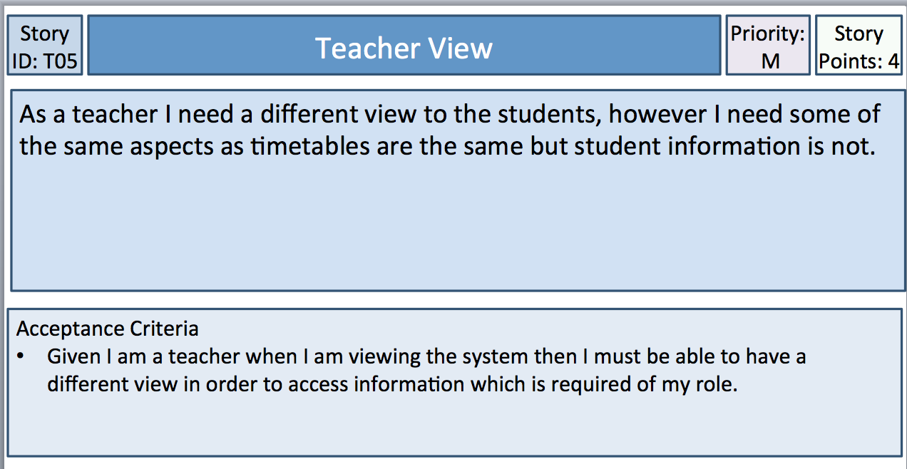

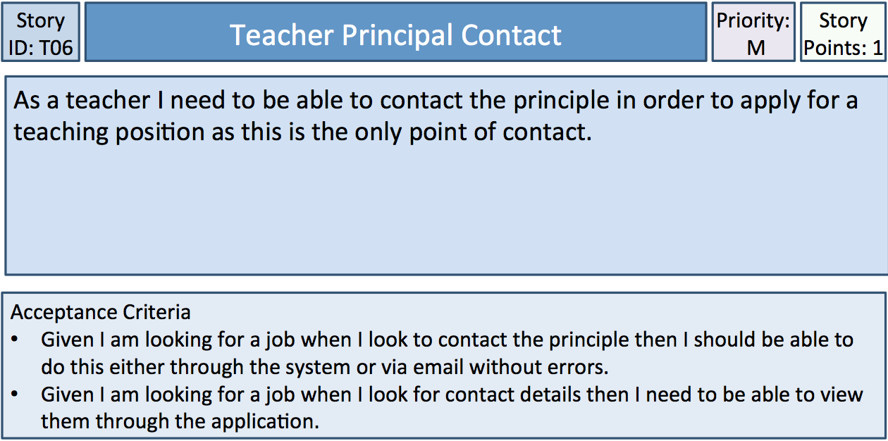

Testing:

This Criterion is about the login system and being able to differentiate different users. This has been implemented quite well and is very user friendly it has been rated 4.5/5 in terms of usability. This satisfies the requirements because it changes permissions and gives different views.

Testing:

This Criterion is about the login system and being able to differentiate different users. This has been implemented quite well and is very user friendly it has been rated 4.5/5 in terms of usability. This satisfies the requirements because it changes permissions and gives different views.

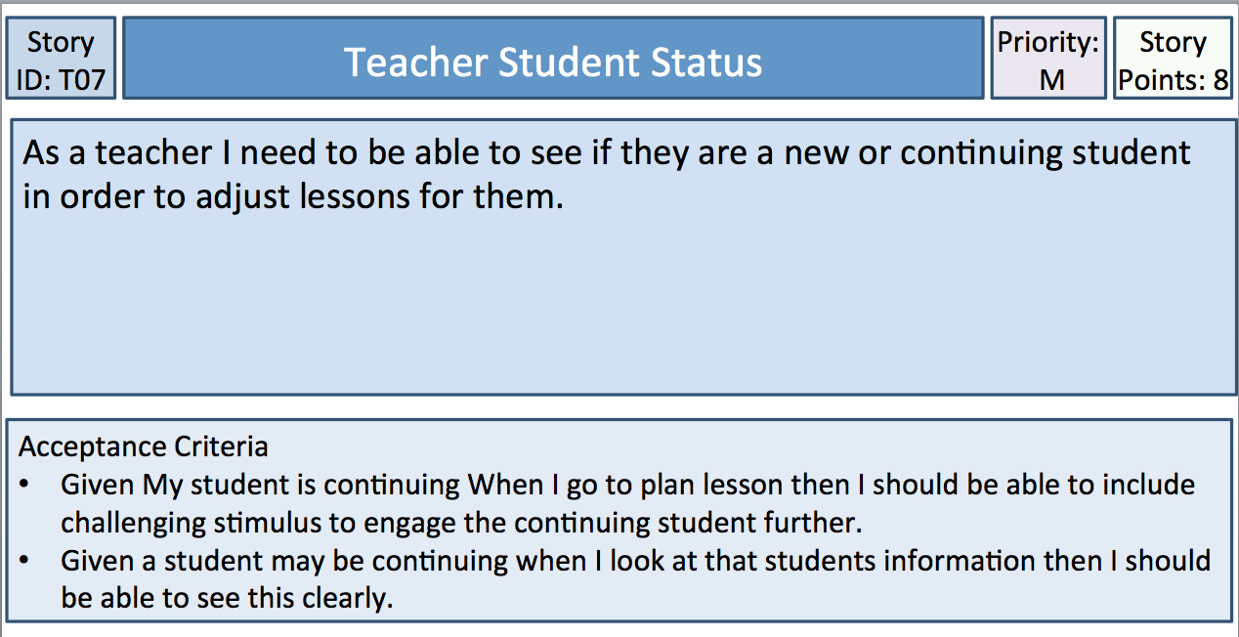

Testing:

This is about accessing certain types of information. This is done through the database and is done quite well as the person is able to view information regarding the students quite an easy task and gives a 4/5 on the usability scale.

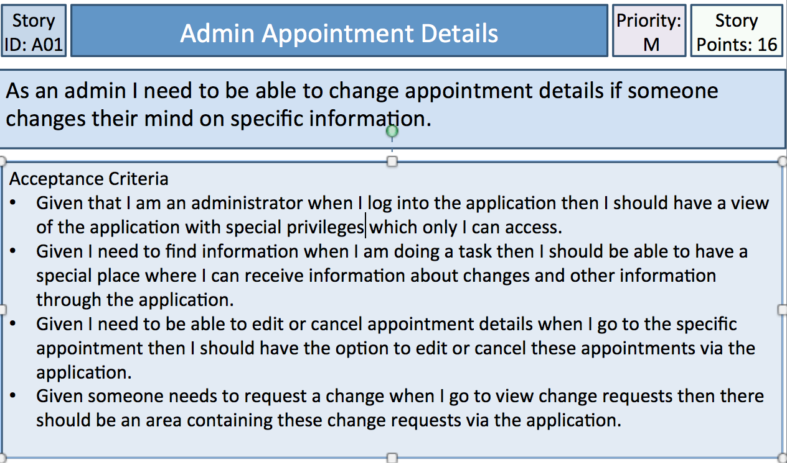

Testing:

The administrator does have a different view and the permissions change within this view and thus this is quite good in terms of functionality and was given a 4.5 out of 5 on the usability scale. The Admin can also add or edit the database being able to book appointments and change others information. As well if someone needs to request a change this is also satisfied within the application as it allows for the admin to do all of this through the database. However the usability of the add tool is not as high as other sections and would receive ad 3/5 because it could have been made easier in terms of usability.

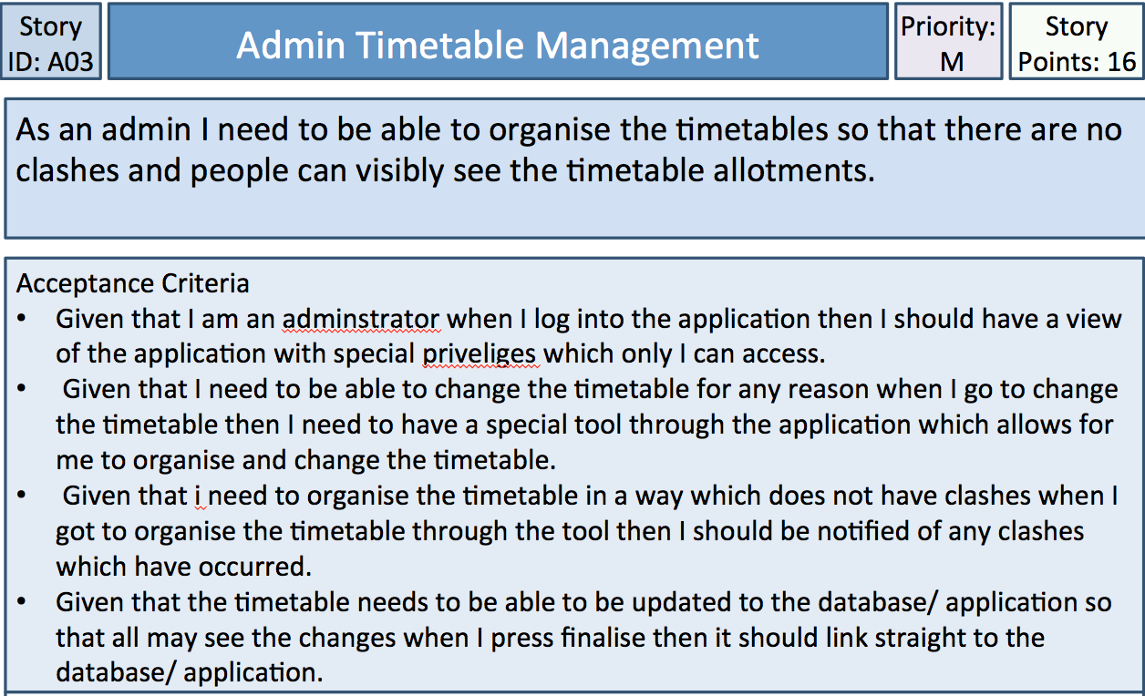

Testing:

The admin has a special view and can make changes where as other cannot altar certain aspects of the application. It is seen that the time table can be edited. The Timetable can also be re-organised by the admin and changed through being edited. The timetable is updated through the database. Overall however there were a few issues with editing the timetable so this would be around about a 3.5/ 5 on the usability scale.

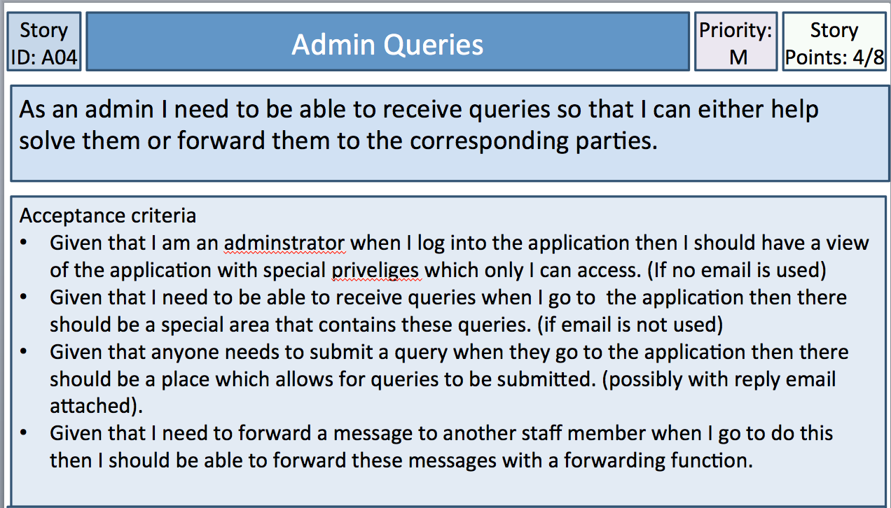

Testing:

The Administrator has a special view compared to others as the Admin is able to edit more things. There is a messaging system for the admin themself as well as for others how ever there is no forwarding system. In terms of satisfying the requirements this does not satisfy all of the acceptance criteria and would receive 3/5 on the usability scale.

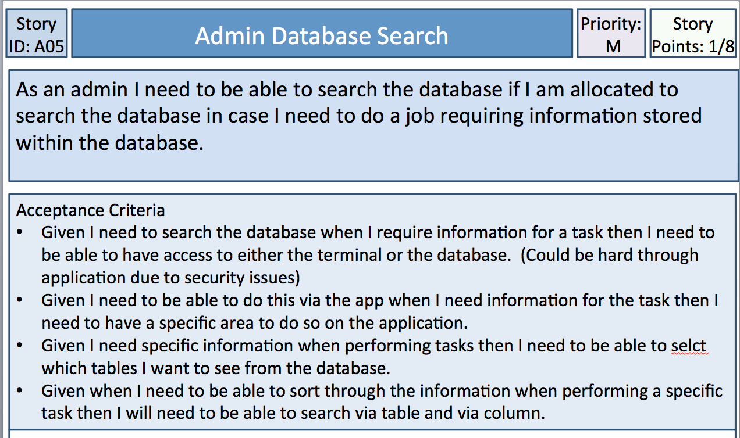

Testing:

The Administrator has the ability to search for information as does other viewers such as teachers or parents. So this is done through the area in the application. I can select which tables I view within the database and I can change what needs to be changed. I can view the tables however it seems that searching is not as easy however if done through terminal I can search. This receives 3/5 in terms of usability.

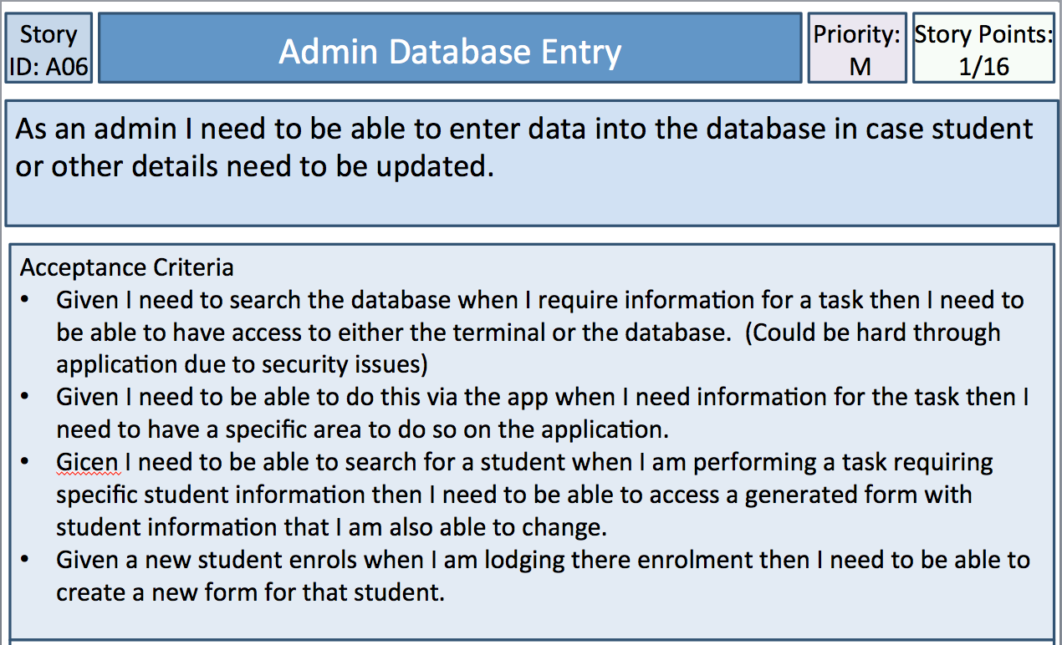

Testing:

The administrator is able to search the database when information is required for a task however this is mainly done through the terminal rather then the GUI. This can also be done through the application. The student information can be accessed via the database. This can be added when adding a new student and can be done through the database. In terms of usability then this

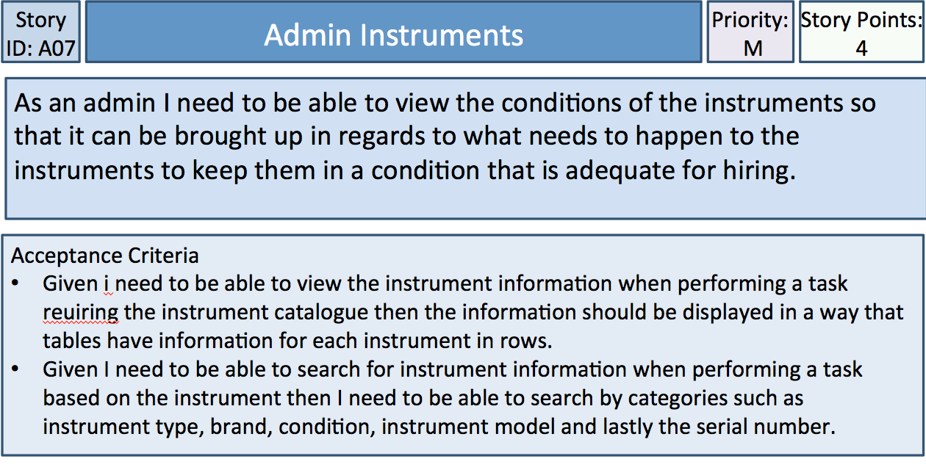

Testing:

The Administrator can view the instrument information within the tables however the admin cannot search it but can view the tables. A search can be done through terminal. However this does not fully satisfy the criteria and would receive a 3/5 and could be better.

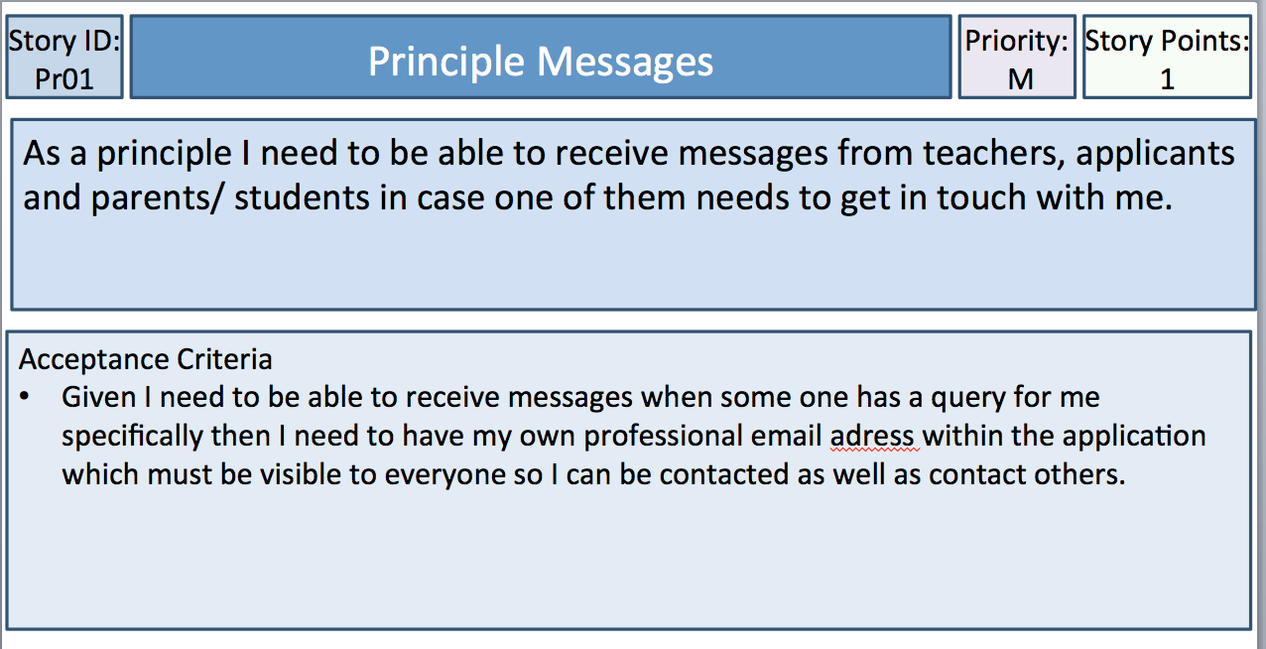

Testing:

The principle is able to receive messages through the messaging tab. This has been satisfied and the principle is also able to contact others. This usability will be rated at around 4/5 as it is quite good in terms of usability.

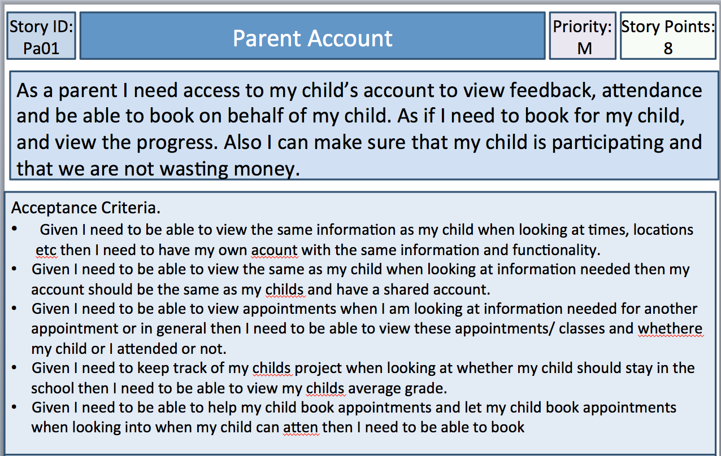

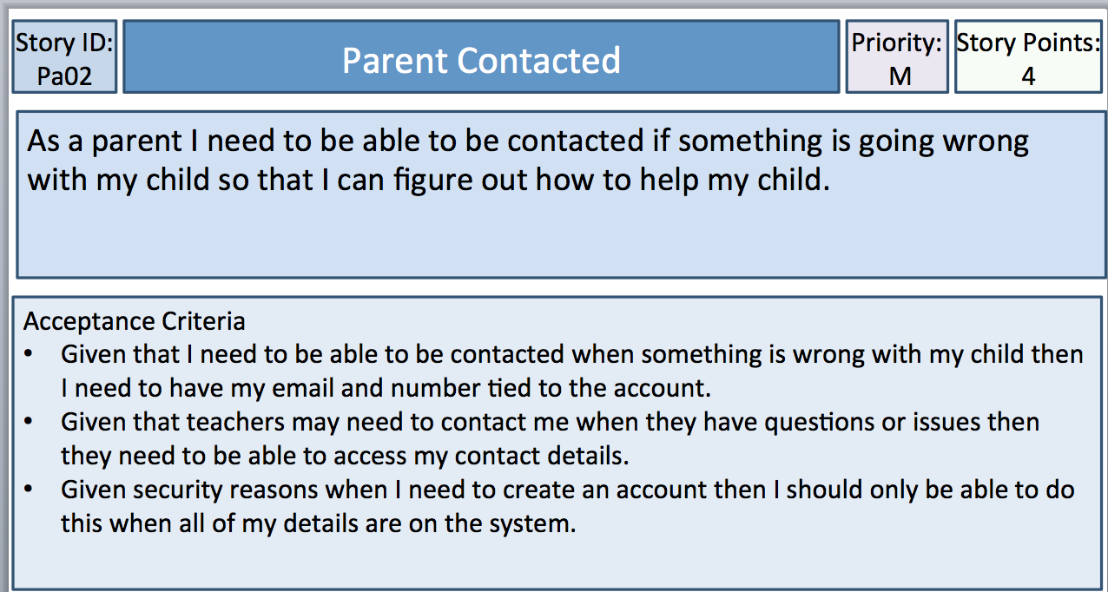

Testing:

This acceptance criteria is about the parent being able to access information about the child. Generally this information is satisfied however there is no access to being able to look at the childs average grade. As well however the booking part is still quite buggy and is harder to use so this receives around about a 3/5 in terms of usability.

Testing:

This is done through the messaging tab and allows for parents to be contacted through the information displayed regarding the child. The teachers can also contact them and also the parent will be given the childs login details. This was satisfied quite well and receives a 4/5 for usability.

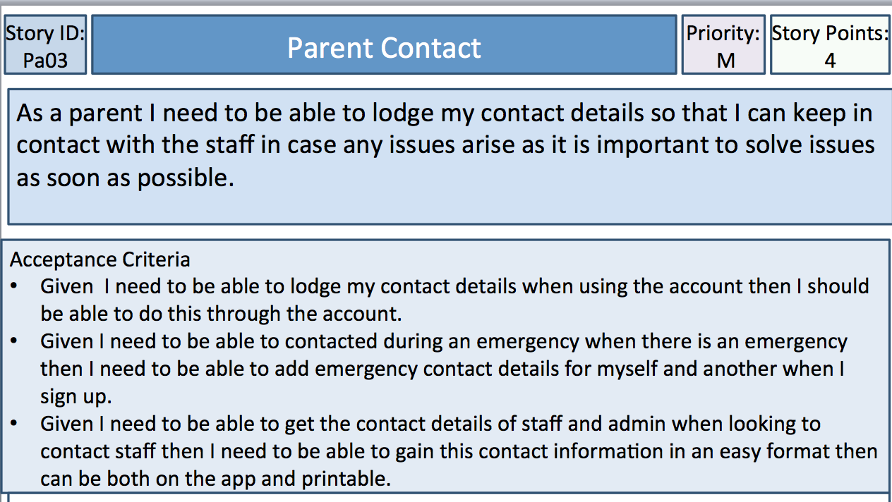

Testing:

The Parent is able to lodge the contact details when using the account as well the parent can also be contacted through the messaging tab as well as through phone regarding the details. This contact info can be gained through the application contacts tab and the messaging tab. In terms of usability this receives a 3.5/5 as there is no forwarding section.

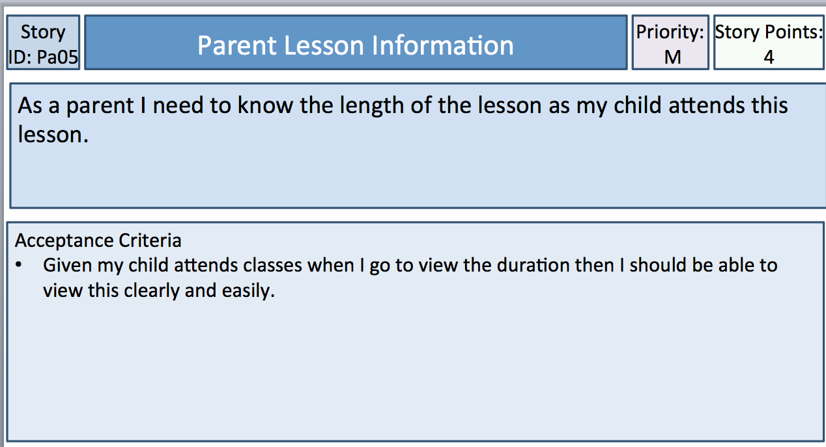

Testing:

The parent can access this quite easily through the timetable function as well as being able to see the students personal timetable. The usability of the is a 4/5 because the timetable could be more visually appealing by more easily segmenting the sections of the time table.

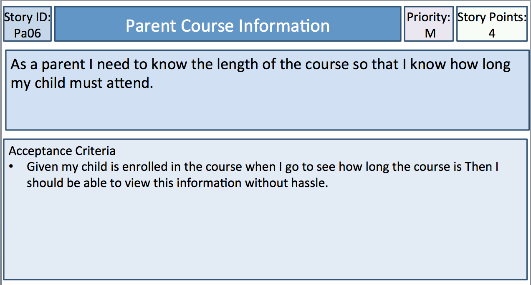

Testing:

This information will be displayed when enrolling in the course, However there does not seem to be a place where this is currently active. This means that the acceptance criteria has not yet been satisfied and thus will be added later. In terms of Usability this would be ranked at around 3/5 because information has been excluded.

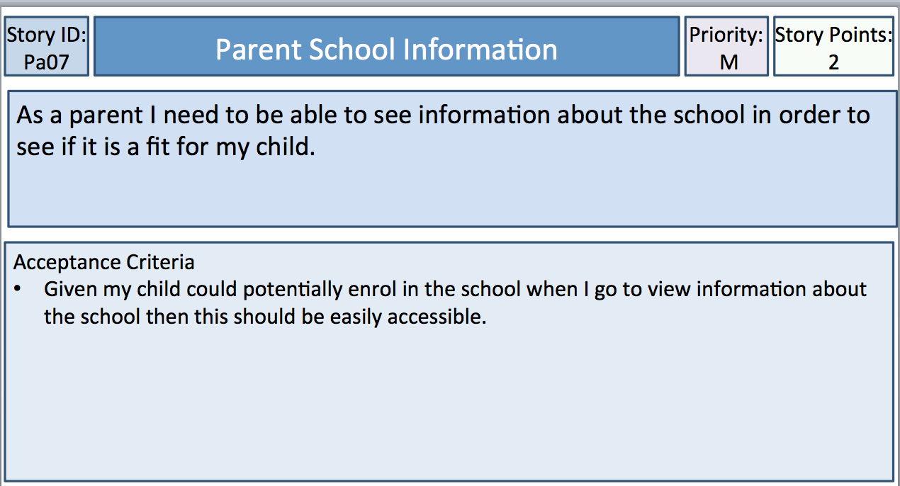

Testing:

This information is accessed through the info tab and it can be seen when accessing this tab. This is quite simple and easy to read so in terms of being able to do this then this means that I can see if my child should enrol here thus this receives a 5/5 in terms of usability.